|  |  |
| --- | --- |
| **Test** | |
| Team I: Fall Validation Demonstration | |
| **Mission Statement** | |
| The Lunar ROADSTER uses the excavator to **groom multiple craters** and **create a circuitous path** around the Moon Yard. | |
| **Objectives** | |
| Demonstrate the rover’s full implementation capabilities in a Lunar-accurate setting. This will include more ambitious tasks such as localization through visual odometry/star-sun tracker and circumnavigation around the Moon Yard. | |
| **Location** | Planetary Robotics Lab Moon Yard |
| **Equipment** | Lunar ROADSTER rover, operations terminal (team laptop), LAN router, FARO laser scanner, star-sun tracker |
| **Subsystems** | Sensors, computations, external infrastructure, mechanical, actuation & electronics, electrical power |
| **Personnel** | Ankit Aggarwal, Deepam Ameria, Bhaswanth Ayapilla, Simson D’Souza, Boxiang Fu |
| **Procedure** | |
| **Prior Setup:**   1. Prepare the Moon Yard with several craters and dunes in a circular path. 2. Scan the Moon Yard with a FARO Scanner to obtain a global map for navigation. 3. Attach and connect all the components and subsystems of the rover. 4. Place the rover in the Moon Yard and calibrate its localization using a star-sun tracker or visual odometry.   **During Demonstration:**   1. Turn on the rover and SSH into the Lunar ROADSTER docker on the operations terminal laptop. 2. Switch the rover to autonomous mode and run the start-up procedure. 3. Observe the rover autonomous grade craters and level dunes in a circular path. 4. After each dozed crater, use the ZED camera to validate whether the dozing satisfies the performance requirements. 5. If anything unexpected occurs press the emergency stop button. | |
| **Validation Criteria** | |
| **M.P.1:** Will plan a path with **cumulative deviation of <= 25%** from chosen latitude’s length  **M.P.2:** Will **follow planned path** to a **maximum deviation of 10%**  **M.P.3:** Will **climb gradients up to 15°** and have a **contact pressure of less than 1.5 kPa**  **M.P.4:** Will **avoid craters >= 0.5 meters** and **avoid slopes >= 15°**  **M.P.5:** Will fill craters of **up to 0.5 meters** in diameter and **0.1m in depth**  **M.P.6:** Will groom the trail to have a **maximum traversal slope of 5°** | |

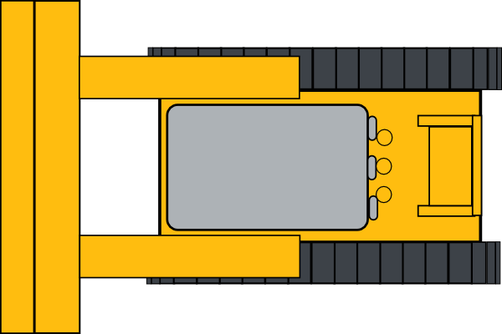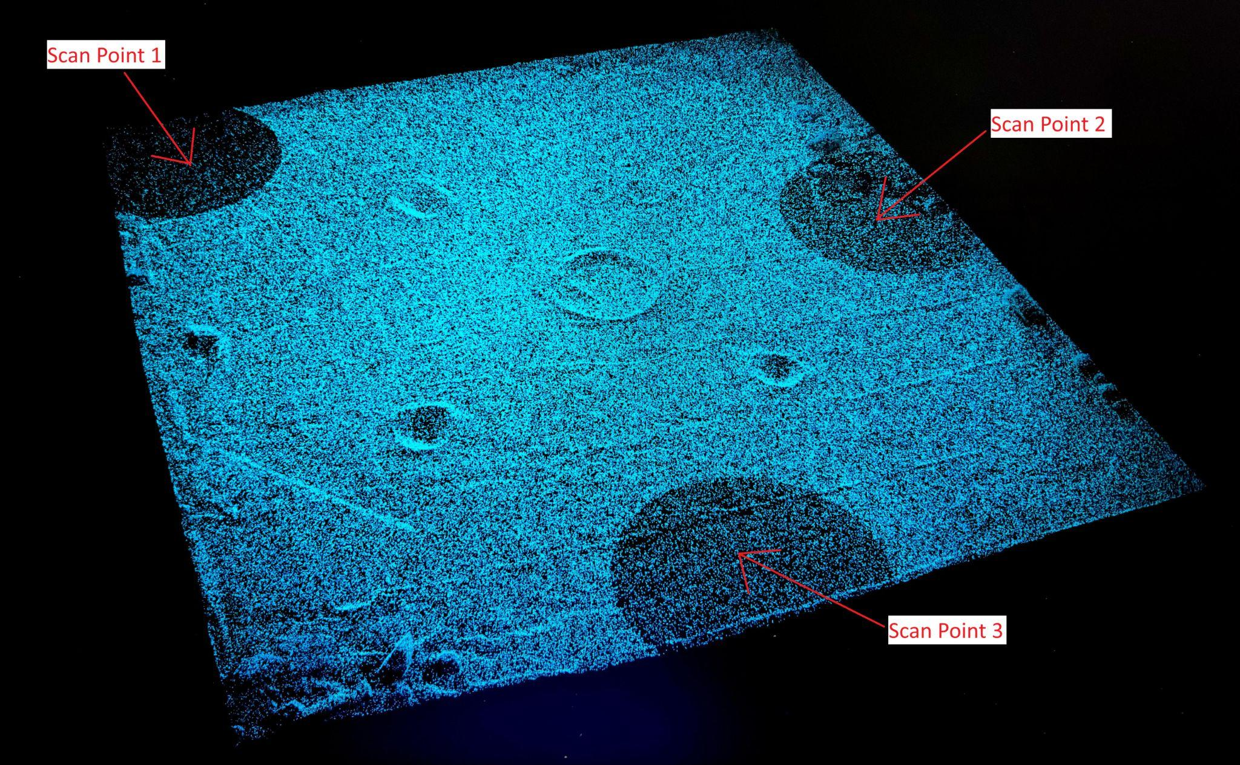

Follow a circular path

Groom several craters in a circular path